## Hardware And Software Specification

### Hardware Requirement

* **Disc capacity :** 10 MB of available hard disk space
* **RAM :** 1 GB (32 Bit) or 2 GB (64 Bit)
* **Processor :** 1.6GHz or faster
* DVD-ROM Drive / USB **Port**

### Software Requirement

* Windows XP (x86) with Service Pack 3 / Windows Vista (x86 & x64) with
* Service Pack 2 / Windows 7 (x86 & x64)
* Microsoft .NET 4.0

## Tools/Platforms used (Hardware/Software):

### Hardware Used

* Laptop with 2GHZ processor
* 2 GB RAM
* 320 GB hard disk (NTFS File System)

### Software Used

* Windows XP (x86) with Service Pack 3 / Windows Vista (x86) with Service Pack 2 / Windows 7 (x86)
* Microsoft .NET 4.0
* Windows Presentation Framework(WPF)
* Windows Communication Framework(WCF)
* Visual Studio 2010 Express Edition (IDE)
* MySQL Workbench
* Dia for Diagram Drawing & Modeling.

# Tools/Platform, Hardware and Software Specification

### Existing System

### WORK To Be Done

The primary roles of the MFMS are to capture information, create new information, store information, and convey information to the user. MFMS can add substantial value in achieving all the objectives of MFI:

* A major advantage of MIS is that it provides easy access to accurate and up-to-date information.
* Detailed information is captured on customers and their activities that can then be used to assess client business to assess impact. It is also useful in tracking historical information of clients.
* Activities, such as disbursements, repayments, deposits, withdrawals and money transfers are completed faster, better controlled and with minimum opportunity for errors.
* Information is produced in user-required formats, which facilitates better understanding, setting priorities, objectives and strategy.
* Key performance indicators provide an overview of the organization’s performance, efficiency and effectiveness of business procedures so that timely adjustments can be made.
* Use of ICT helps make MFI services more interactive, accessible and transparent.
* In terms of innovation, ICT provides full flexibility to structure products and services to the needs of its target group.
* Efficiency and productivity of staff is increased, as they are able to manage more products, customers, and transactions in less time.
* To meet target market needs, introduction of new products and setting procedures is easy and can be quickly applied throughout the branch network.
* It can also provide the flexibility to integrate with other applications and delivery mechaniMMM
* MFMS will provide low transaction cost, increases productivity, reduces risk of failure, and pushes the boundaries beyond bricks and mortar infrastructure to carryout business.

## Requirements Specification

## Technical specification

* **Front End/ GUI Tools:** Windows Presentation Framework (WPF)
* **IDE:** Visual Studio 2010
* **Framework:** Microsoft .NET 4.0
* **Database:** MySQL
* **Database Tool:** MySQL workbench CE
* **Operating Systems**: Windows XP, Windows 7
* **Cloud Technology**: Google Drive, Google forms

# Complete Data Structure

## Module Description

## Estimation

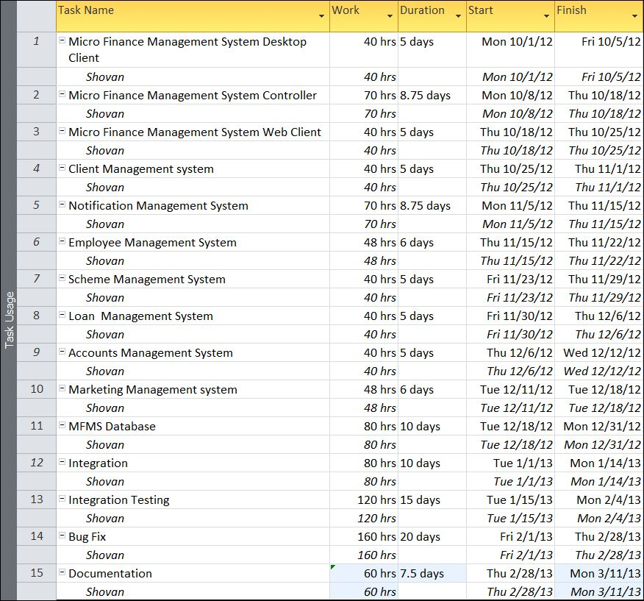

## Data Structure

## Implementation Methodology

* Object Oriented Programming methodology will be adopted
* User interface development will be done in MVC architecture using Windows Presentation Framework.
* Relational DBMS MySQL will be used to implement & execute SQL query to database.

Agile Software Development model will be used while developing this software.